

|  |  |
| --- | --- |
|  | Lab 4: Cosmos DB and ASP.NET. |
|  |  |
|  | Akshar Panchani ID- 202101522  IT457 Cloud Computing  3/2/24 |

**Question – 1**

1. Create NoSQL Azure Table storage design for the following problems and implement crud operations using your opted language SDK to validate the working of the design.

a. A gift shop wants to start a portal which allows users to view various items present in its store. The items details like name, price, available quantity etc. are shown. Along with that, pictures of item from different angles are also available. There’s a high-res image also available for every item:

Items to upload in gifts container:

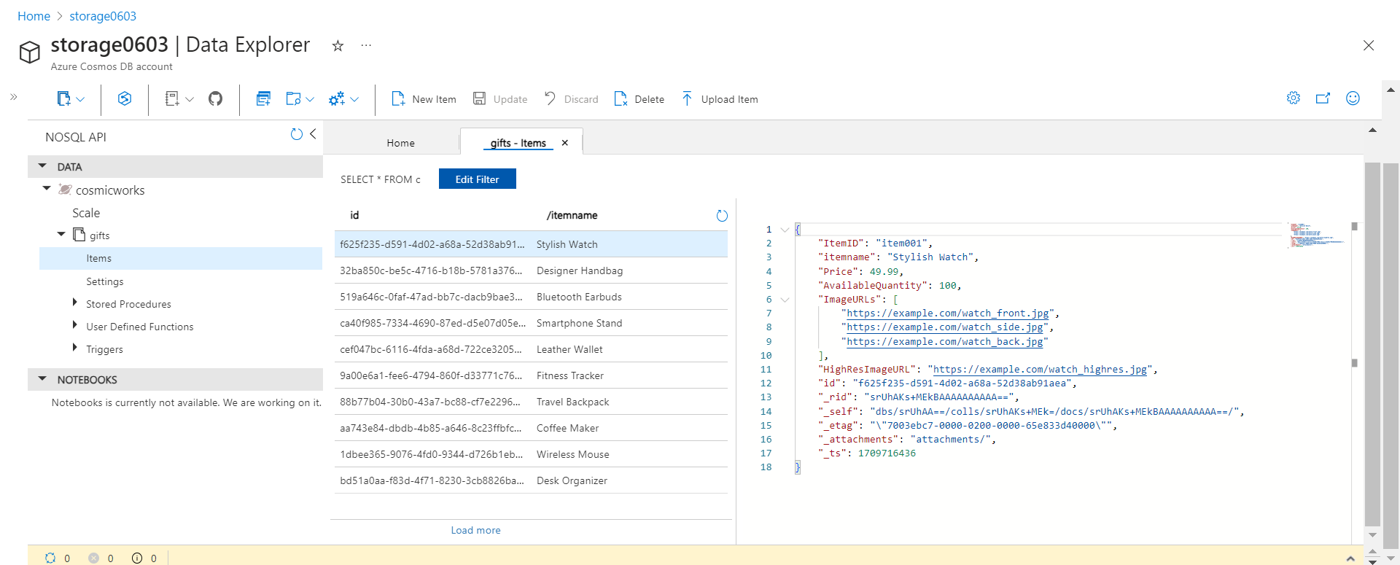

Inserting Item and inserted list: -

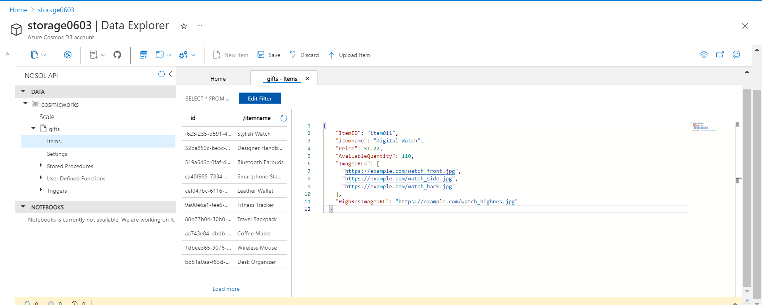

Deleting item and deleted items: -

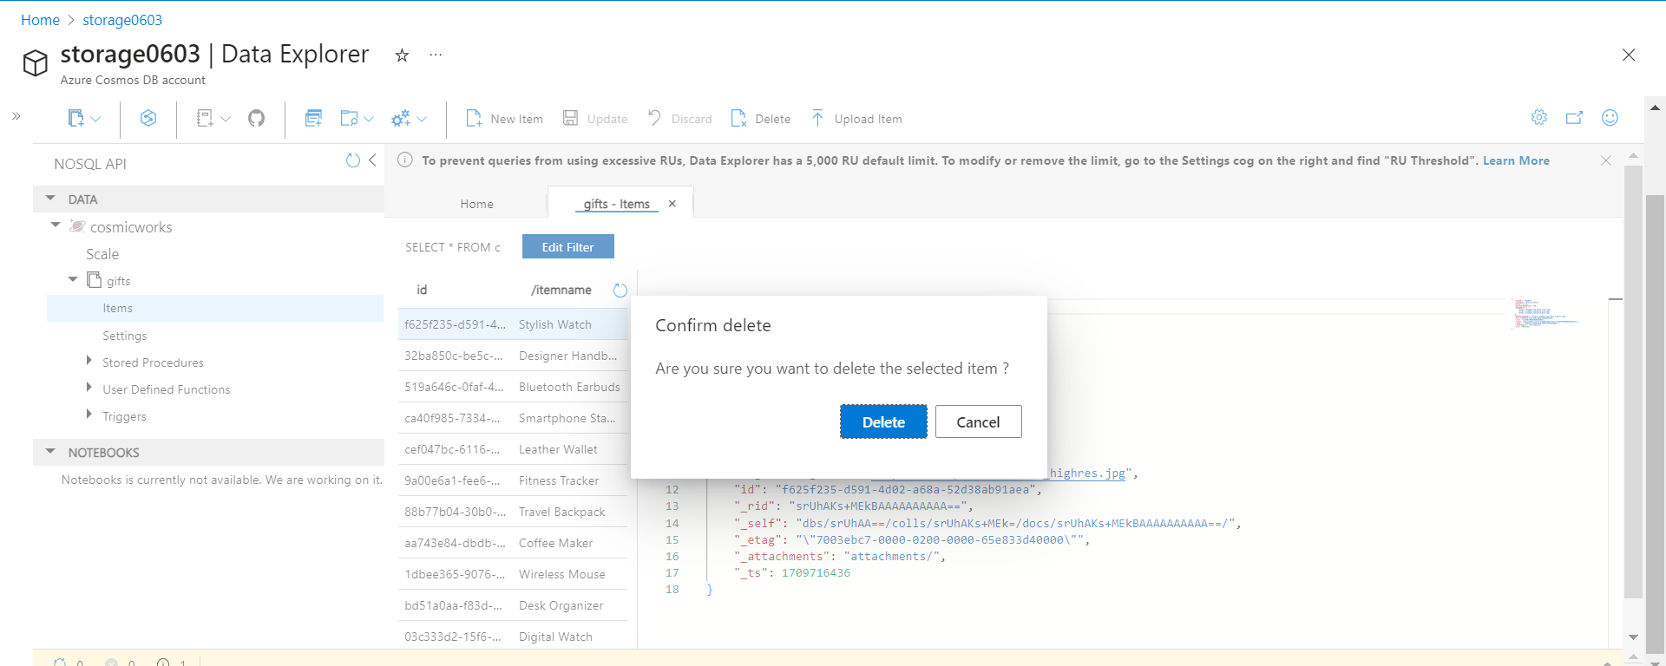

Updating item: -

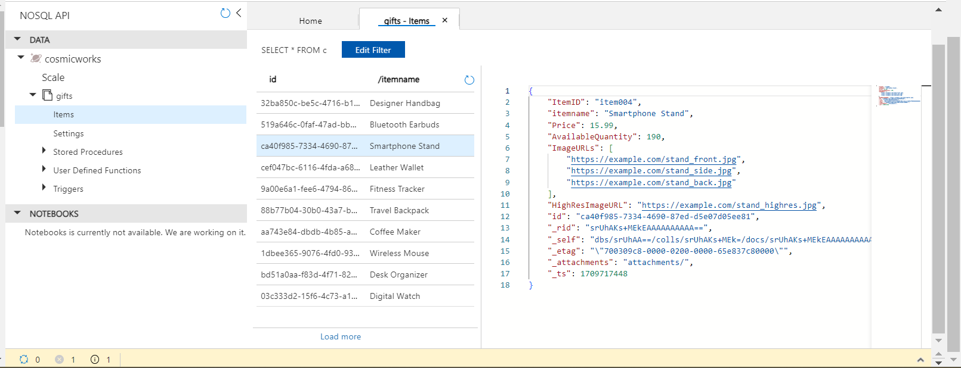

Query Execution: -

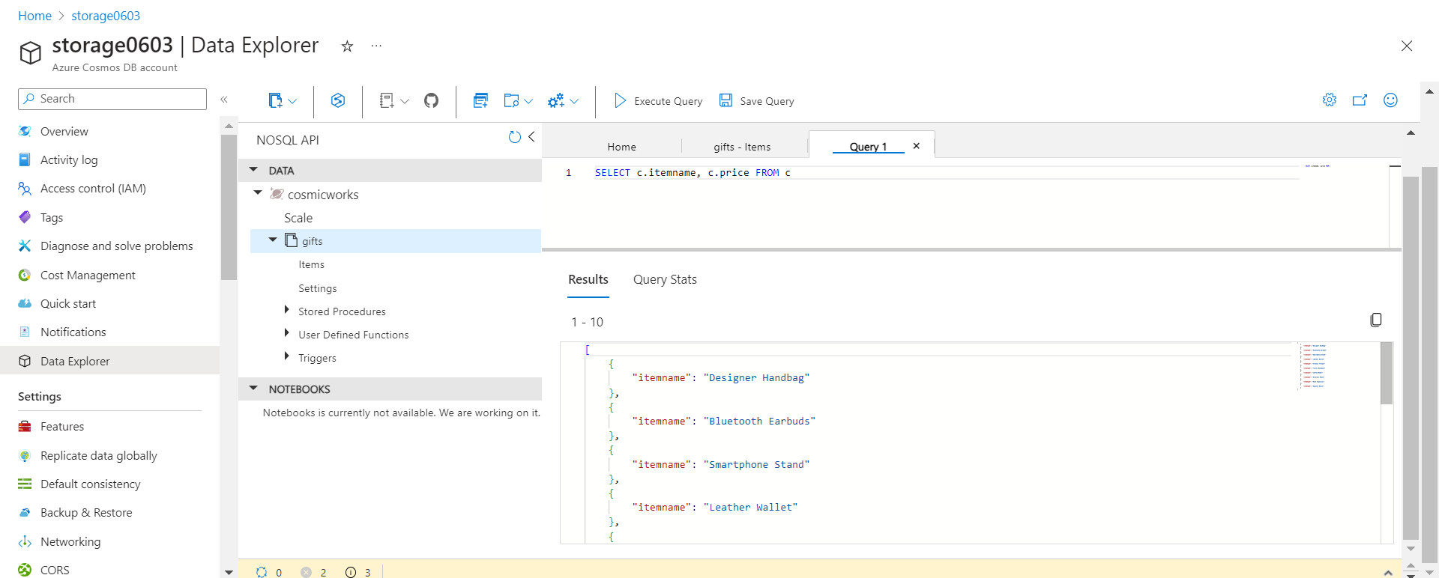

A company has training period for employees. It has around 500 training modules that an employee needs to cover over the period of 6 months. A module could be a video, document, e-book or other form or content. The requirement is to track the status of modules covered by employee over the training period:

Items uploaded in modules container:

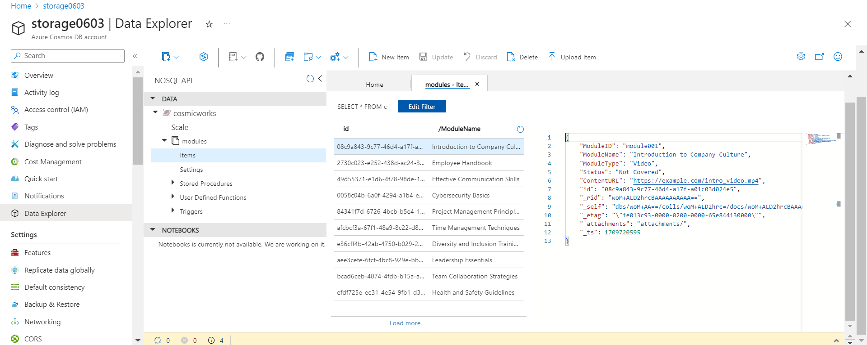

Inserting Item and inserted item: -

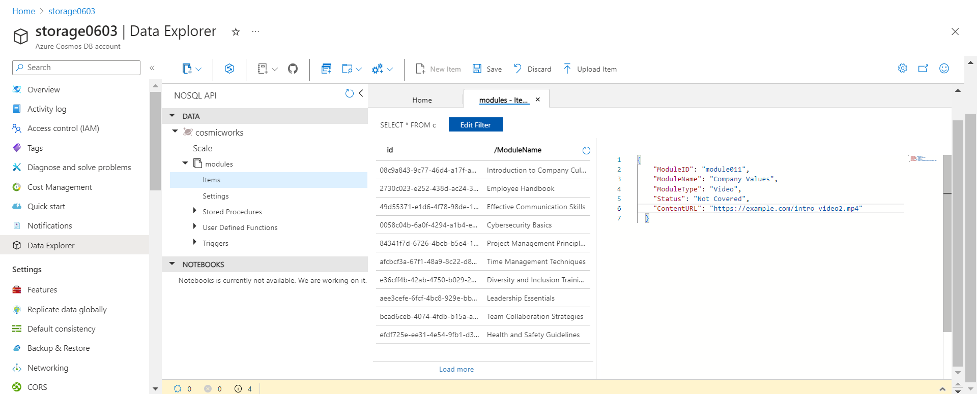

Deleting item: -

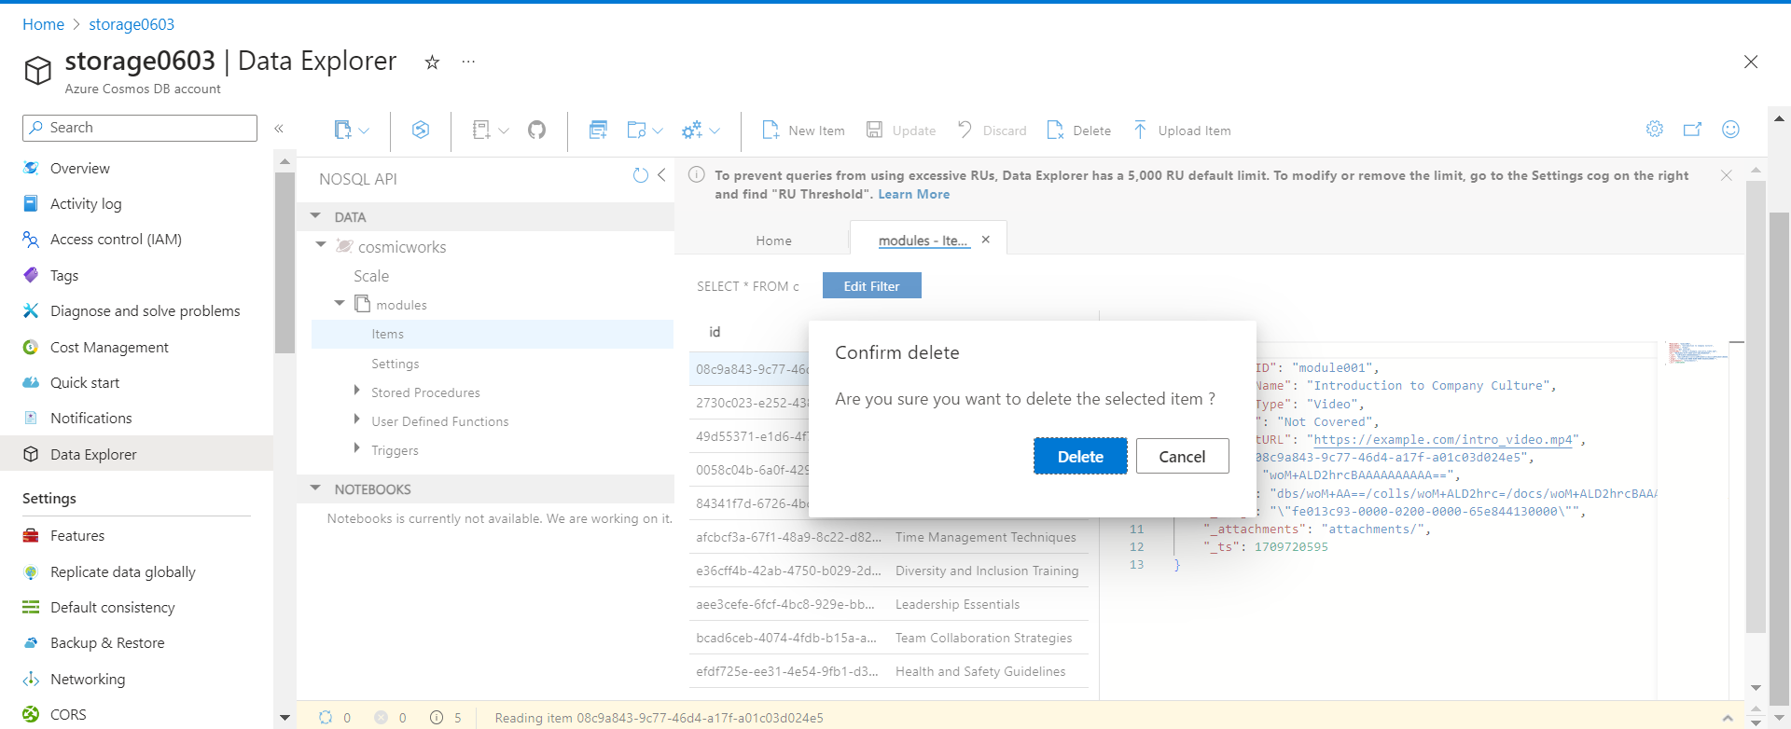

Item deleted and Updating item: -

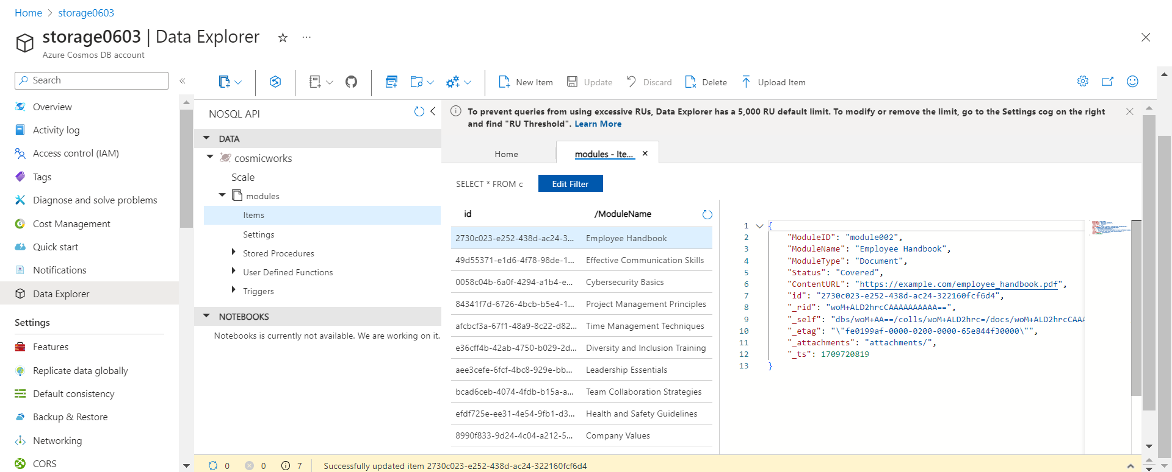

Query Execution: -

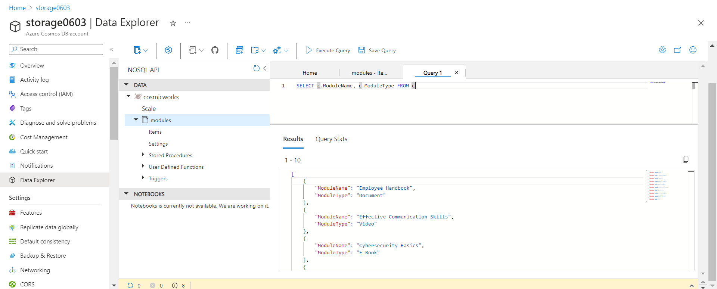

**Question - 2**

Develop an ASP.NET web application with Azure Cosmos DB for NoSQL

Keys in Cosmos DB account: -

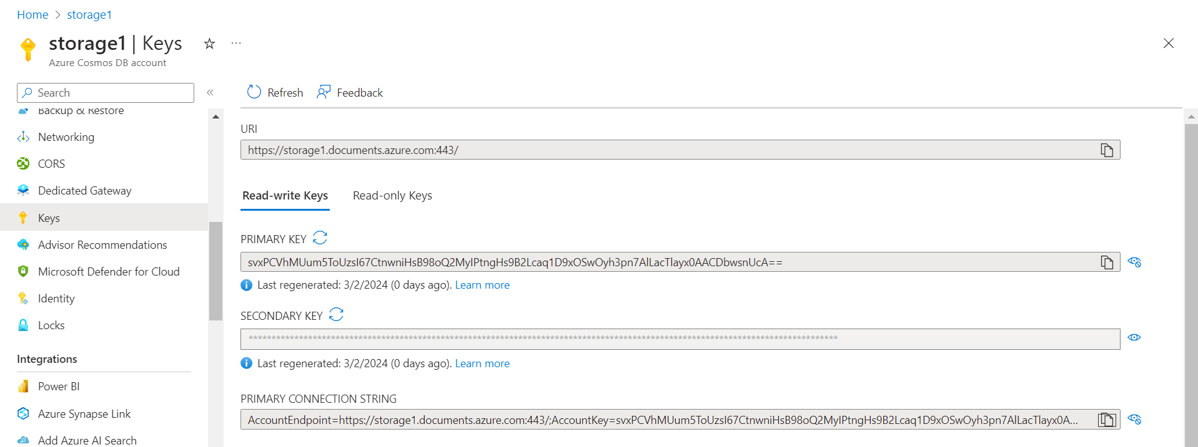

Data Population: -

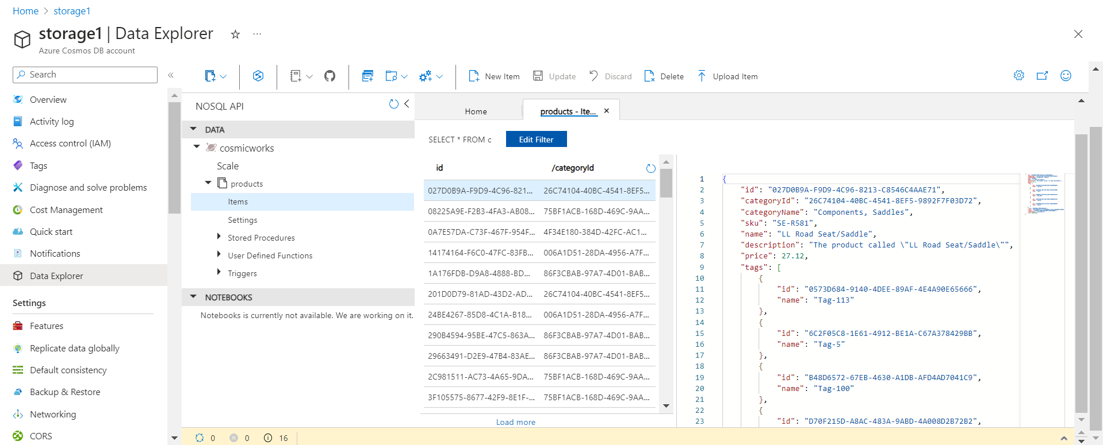

Query Executions: -

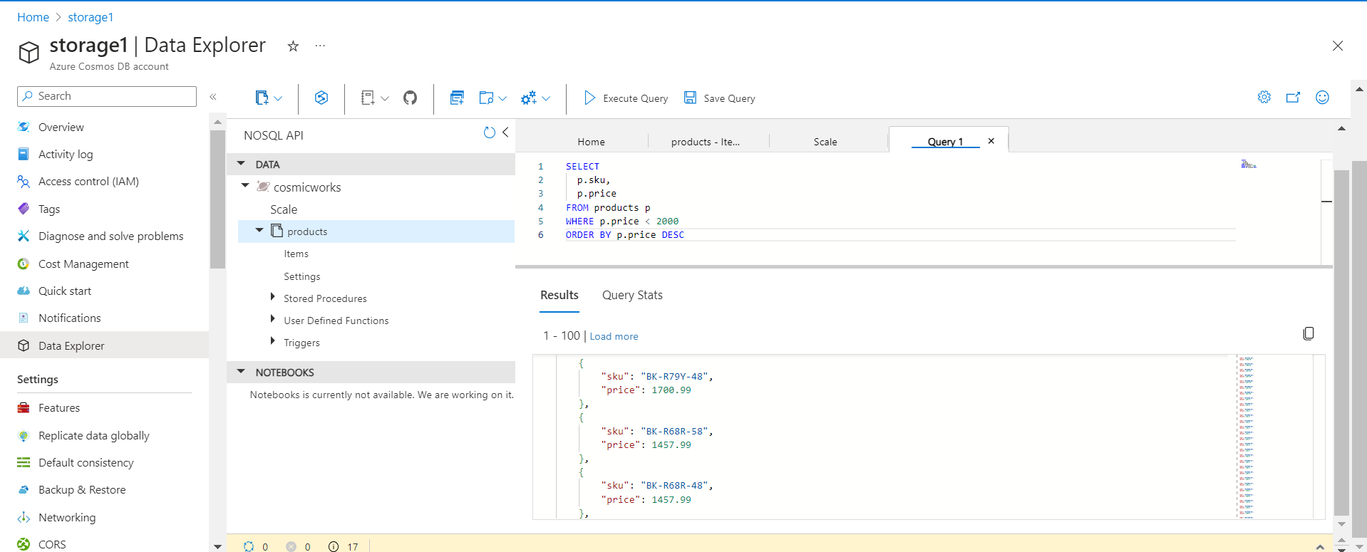

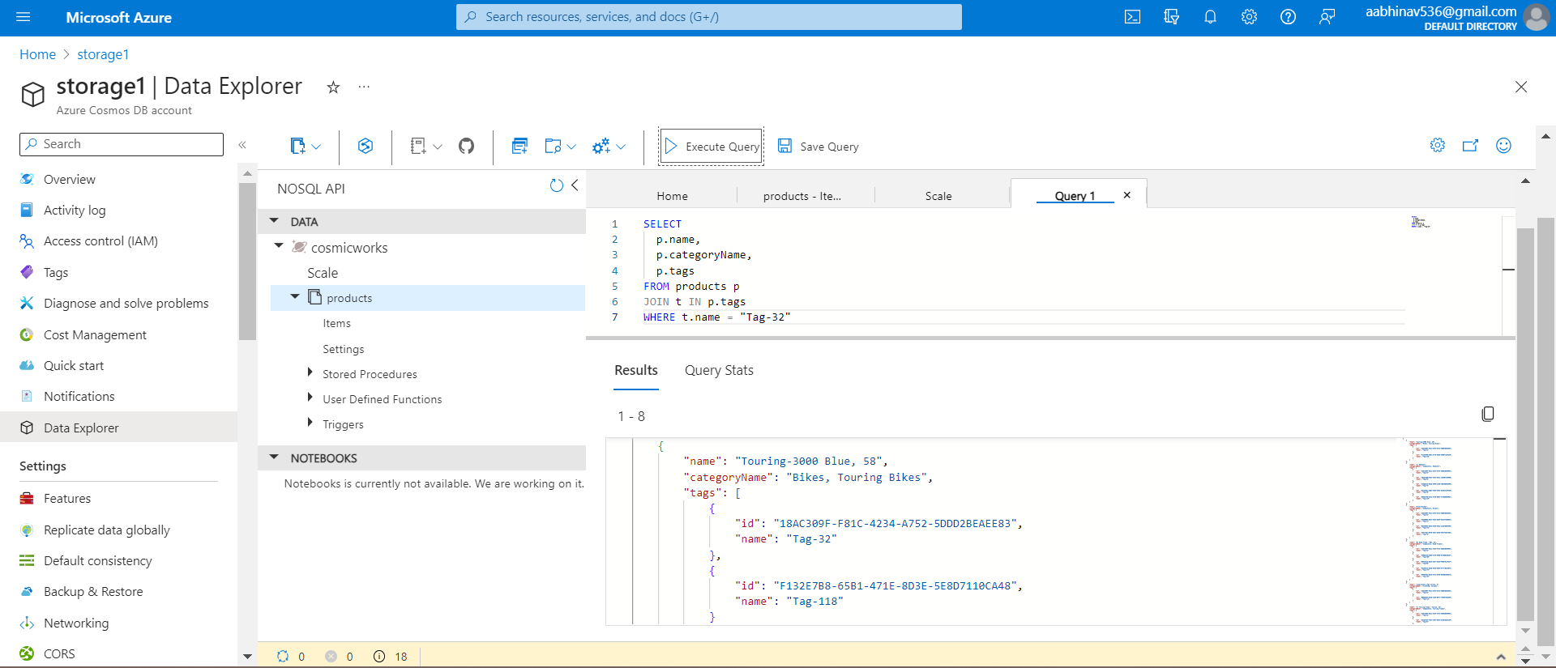

Building and running application:-

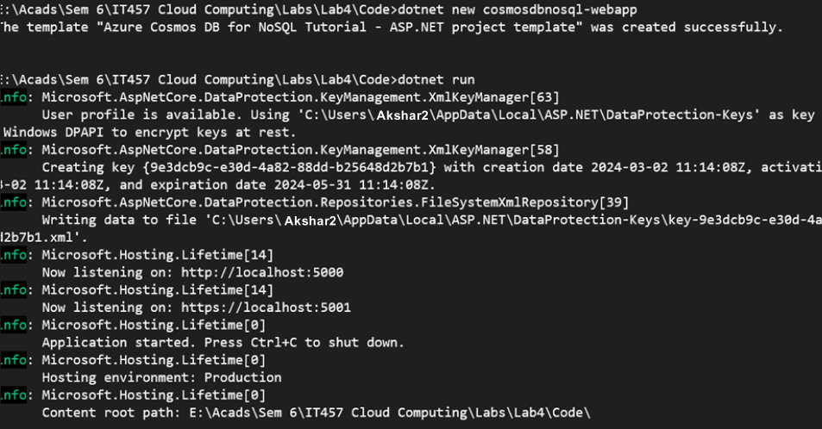

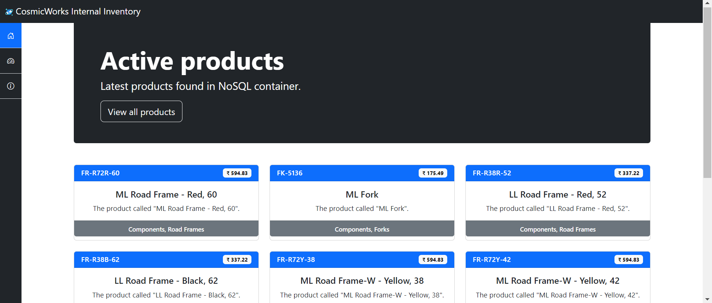

Adding code and running the application: -

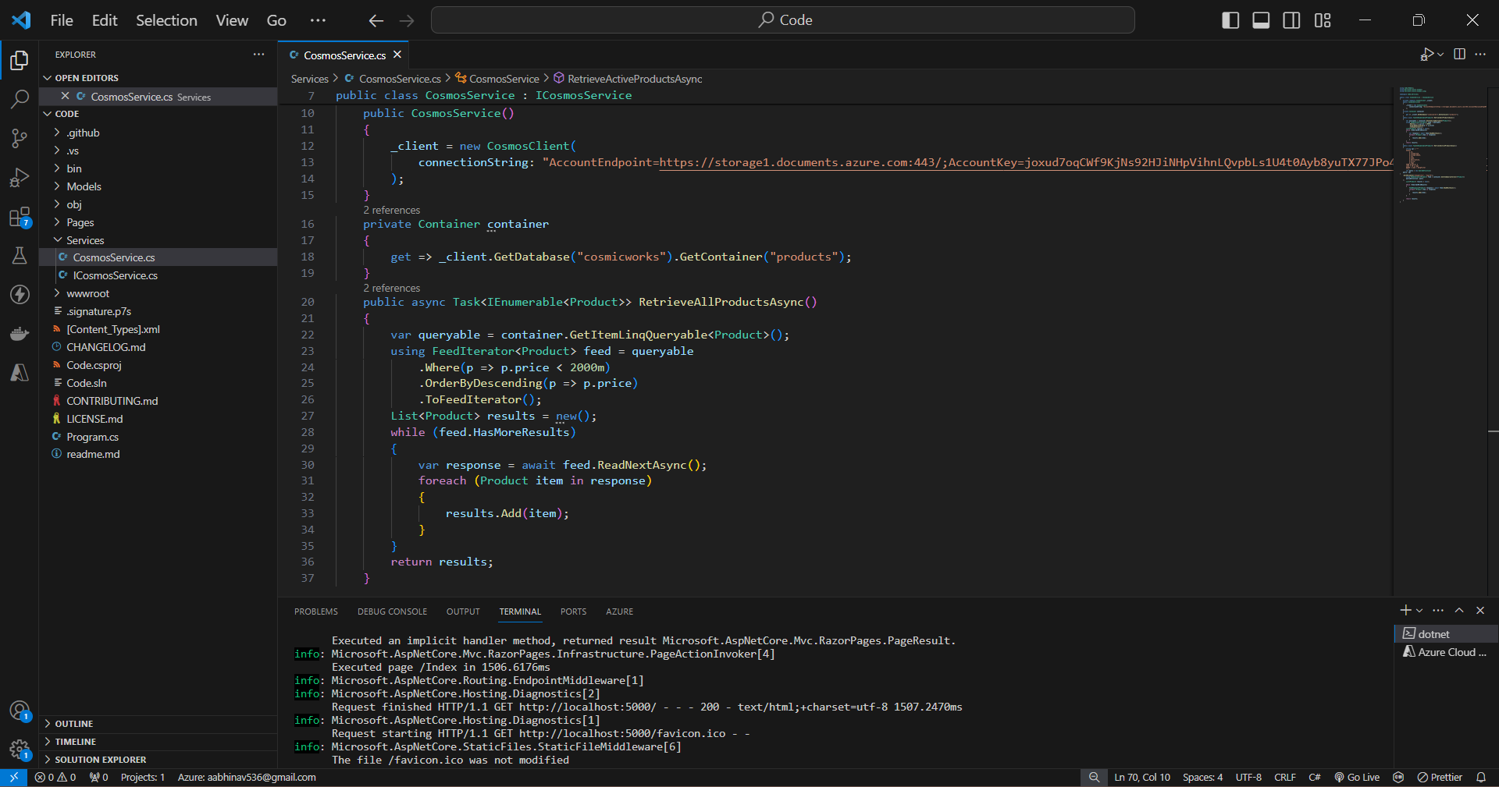

Updated list of products from the Azure Cosmos DB database with prices descending

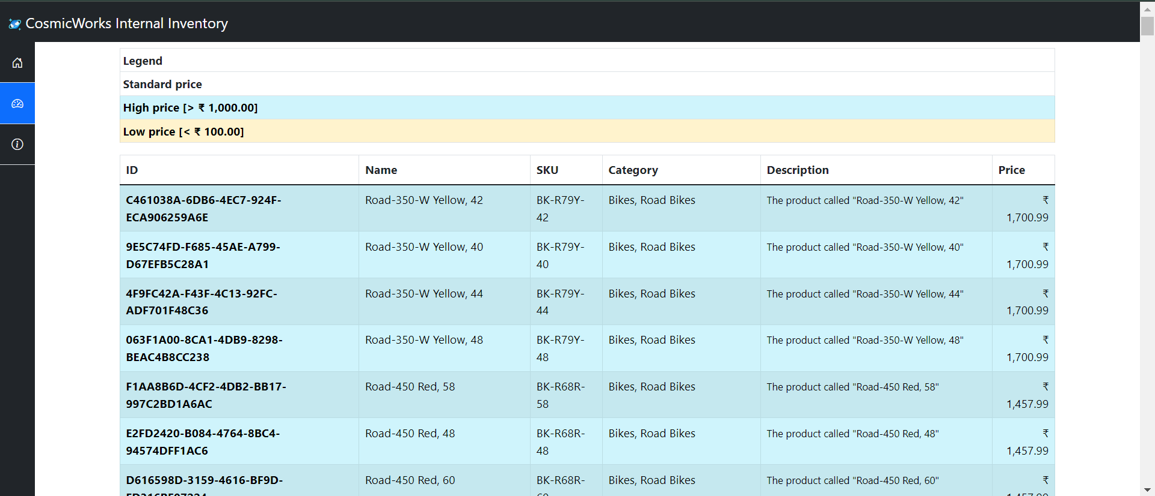

Azure Cosmos DB – end to end example:

Storage account, database, container, and items: -

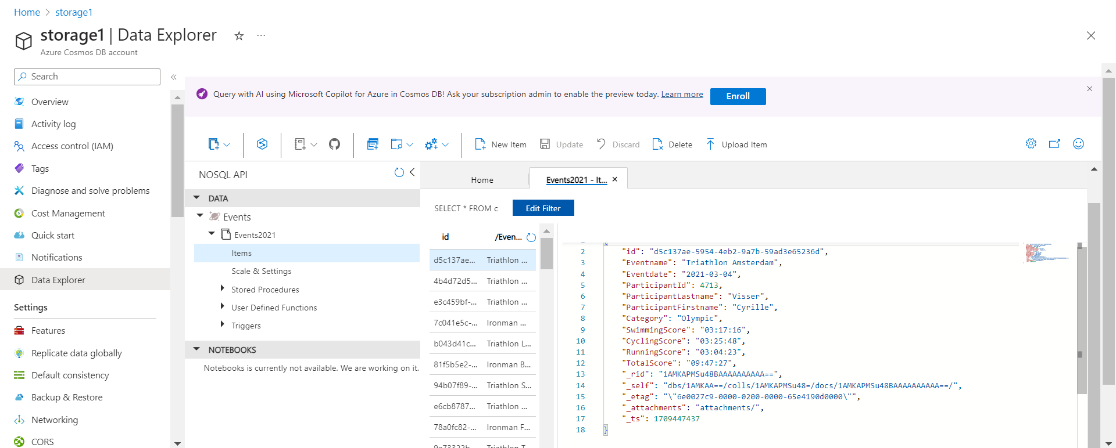

Executing query: -

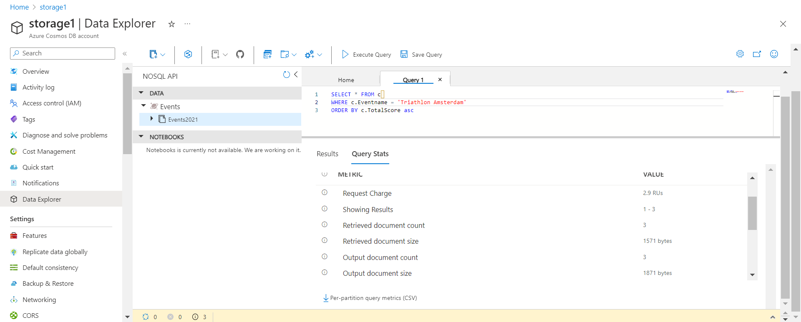

Old indexing policy: -

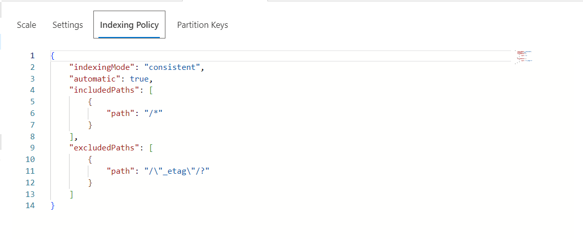

New indexing policy: -

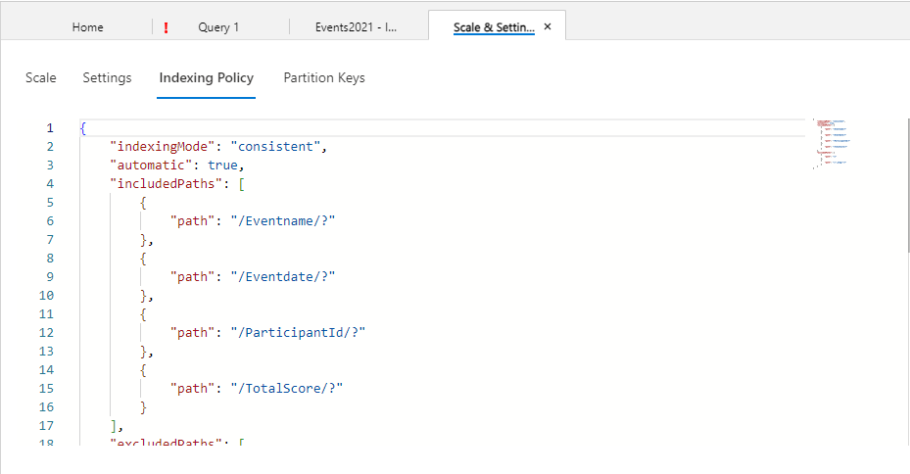

Optimised querying: -

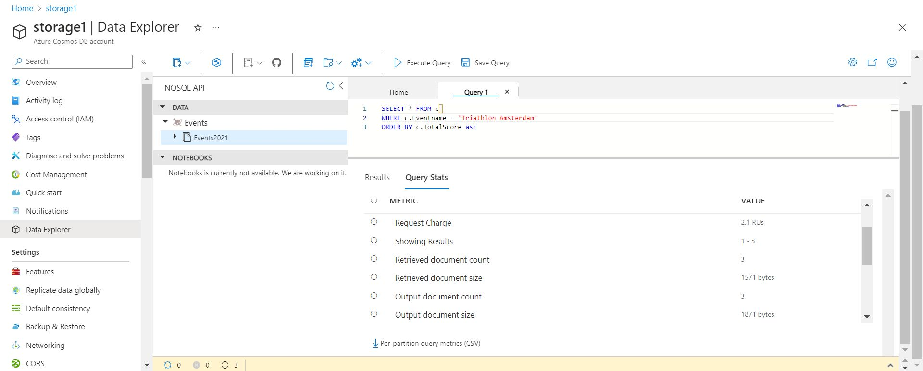

Azure Cosmos DB for Table for .NET

Creating Cosmos DB account using Azure PowerShell:

l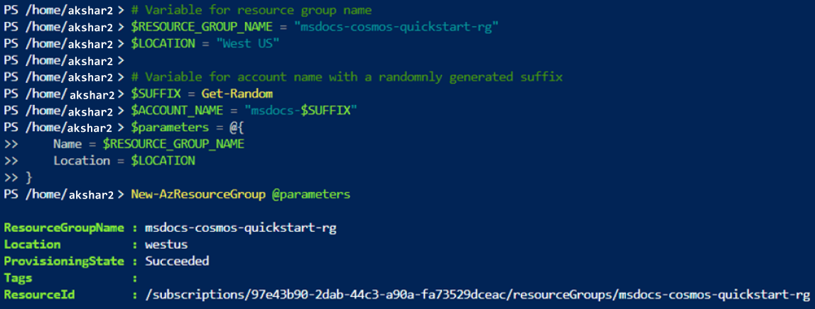

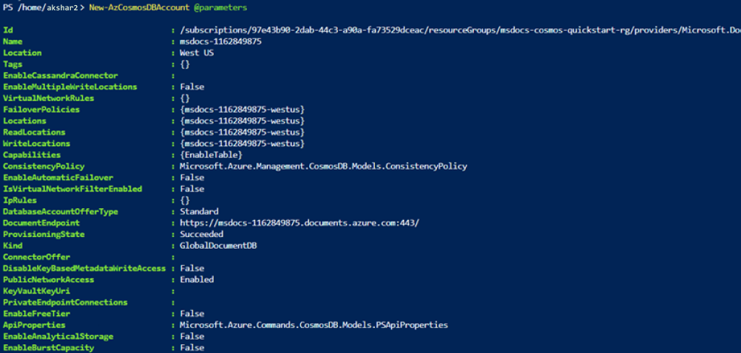

Getting document endpoints: -

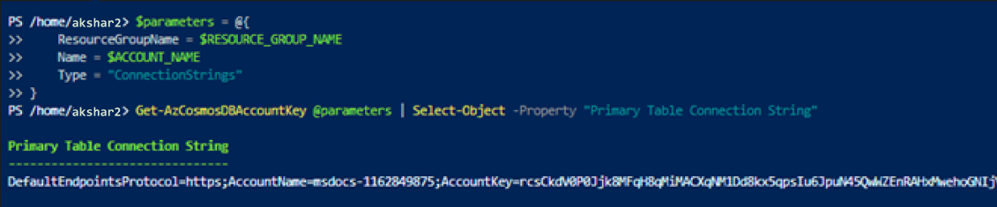

Code: -

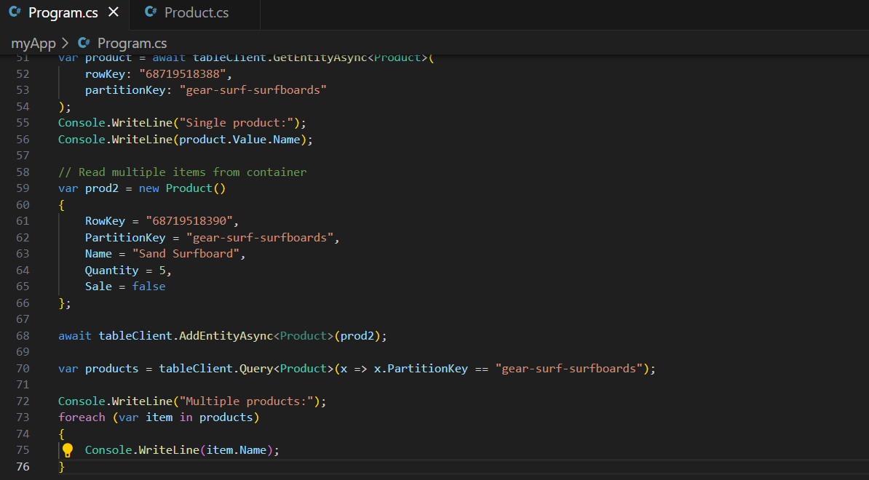

Output: -

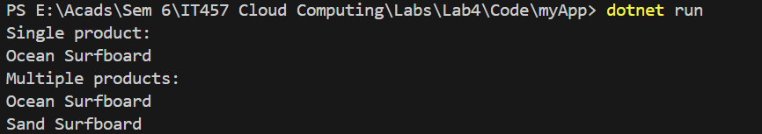

Output on Azure portal: -

